1. Agenda:
   1. We will start building our first Camel Route -> Timer.
2. Timer route is a route that runs every X seconds.
3. 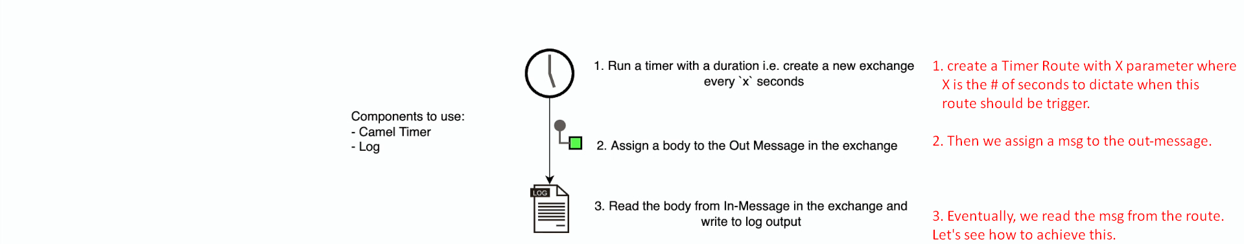
4. 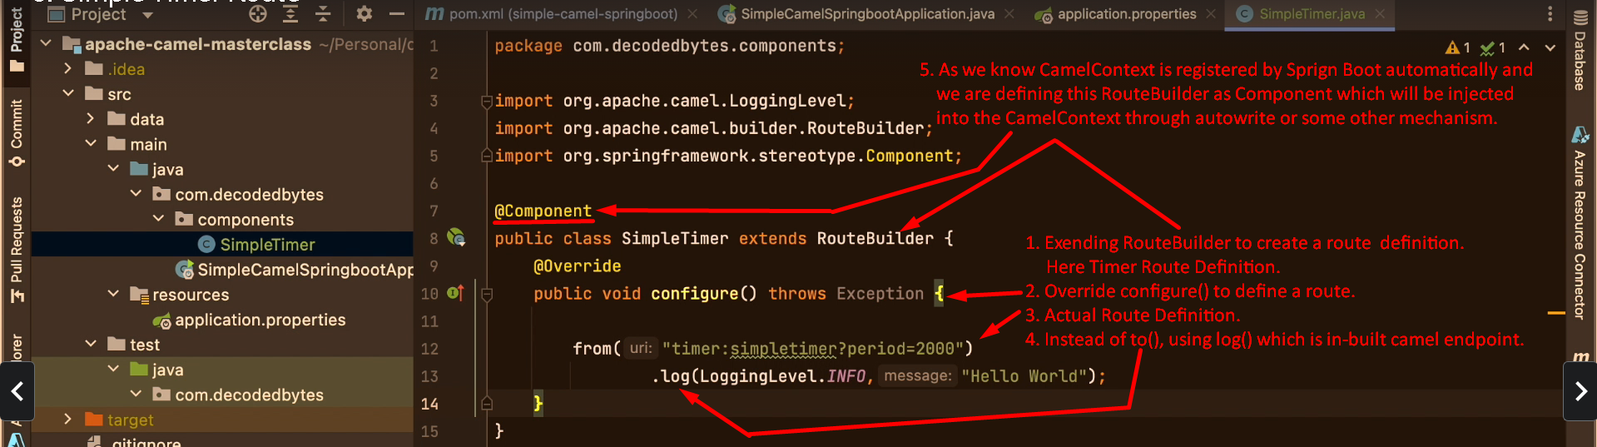
5. 